**Assignment -2**

**Python Programming**

|  |  |
| --- | --- |
| Assignment Date | 27 September 2022 |
| Student Name | 1. Ravikumar |
| Student Roll Number | 912419104024 |
| Maximum Marks | 2 Marks |

**Question:**

**Build a python code, Assume u get temperature and humidity values (generated with random function to a variable) and write a condition to continuously detect alarm in case of high temperature.**

**Solution:**

**PROGRAM CODING:**

import random

import time

while(True):

temperature=random.randint(0,1024)

humidity=random.randint(0,150)

print(f' Temperature={temperature}')

print(f' Humidity={humidity}')

if temperature>600:

print('Temperature is high..\n')

print("alarm is on")

time.sleep(5)

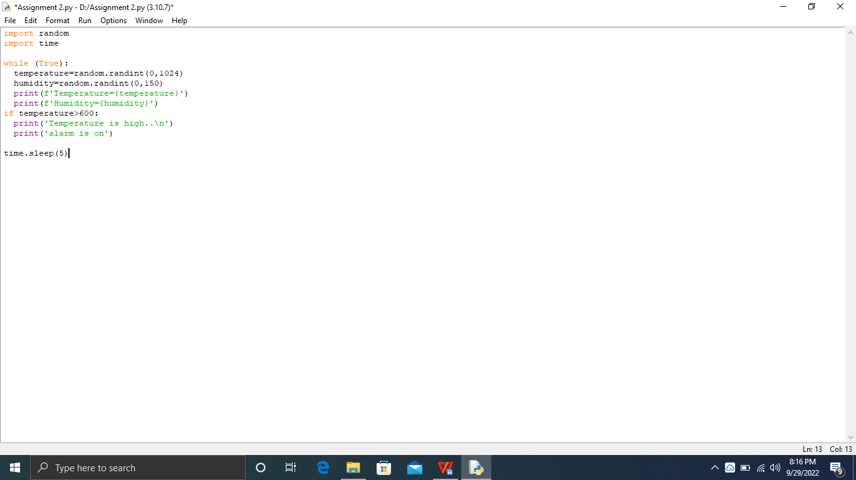

OUTPUT:

